


Nethergate Academy Relationships, Sex and Health Education Policy

Version | 1.2 Final
Document author | EDPT-AC

Classification | Internal
Updated | September 24
Review | September 26

Contents

- Values and Ethos 3
- Aims 3
- Statutory Requirements 4
- Definition 5
- Curriculum Design 6
- Delivery of RSHE 8
- Roles and Responsibilities 8
- Safeguarding 9
- Parents right to withdraw 10
- Training 10
- Monitoring Arrangements 10
- Assessment 11
Appendices
Appendix 1: EYFS Curriculum Map 13
Appendix 2: PSHE Association Programmes of Study KS1 to KS5
By the end of primary school pupils should know 14
By the end of secondary school pupils should know
Appendix 3: Parent Form: withdrawal from sex education within RSHE 26
Appendix 6: Right to Withdrawal - DfE Summary 27

Values and Ethos
This policy covers the GAT approach to how we expect our academies to support children’s development and understanding around relationships and physical development. The policy is developed in line with the expectations of the DfE Statutory Guidance for RSHE (2019). This policy has been developed by Greenwood Academies Trust and has been personalised to meet the needs of Nethergate Academy. GAT require each academy to have in place a policy for RSHE. We define 'relationships and sex education' as a curriculum which will help our children grow in confidence and understanding relating to how they as individuals will develop, grow and mature into responsible individuals.
  - We believe relationships and sex education is important for our academies because it will help our children to value positive relationships and to have the confidence and strength of character to identify and lead a healthy lifestyle.
  - We view the partnership of home and academy as vital in providing the context of open discussion, honesty and support.

The intended outcomes of the programmes of study are that pupils will:
    - Know and understand, how as individuals our bodies change as we get older.
    - Understand they have the right to be safe.
    - Understand they have a responsibility to be a responsible, valued member of the academy.
    - Develop the skills needed to lead a healthy lifestyle.
    - Develop the attributes of positive relationships.

Aims
The aims of relationships sex and health education (RSHE) are to:
- Provide a framework in which sensitive discussions can take place
- Prepare pupils for puberty, and give them an understanding of sexual development and the importance of health and hygiene
- Help pupils develop feelings of self-respect, confidence and empathy
- Create a positive culture around issues of sexuality and relationships
- Teach pupils the correct vocabulary to describe themselves and their bodies
- Support the academy ethos of nurturing a caring community

Statutory Requirements & Legislation
Greenwood Academies Trust follows the revised Department for Education statutory guidance that states from September 2020 all primary and secondary schools must deliver relationships education. In implementation of the RSHE curriculum the requirements and scope from the DfE are:

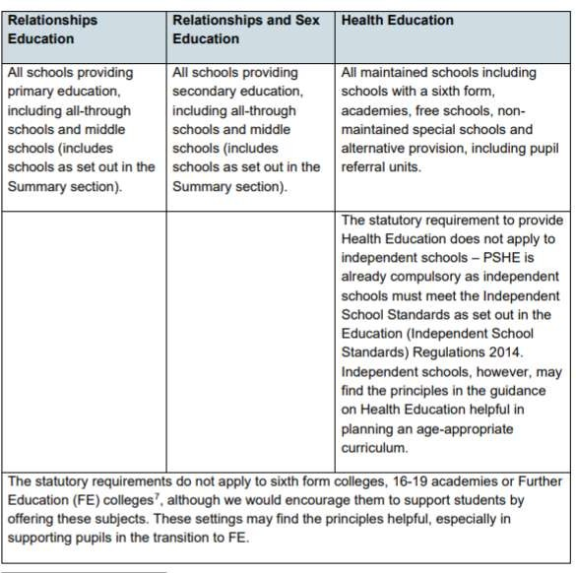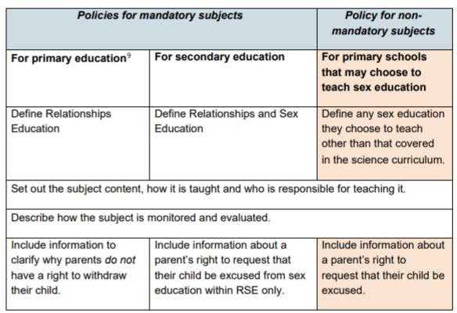

Documents that inform the school's RSHE policy include:
- Education Act (1996)
- Learning and Skills Act (2000)

- Education and Inspections Act (2006)
- Equality Act (2010)
- Locally Agreed RE Syllabus in line with SACRE Guidelines
- Supplementary Guidance SRE for the 21st Century
- Keeping Children Safe in Education – Statutory safeguarding guidance
- As an academy we must provide relationships education to all pupils as per section 34 of the Children and Social work act 2017. Within Greenwood Academies Trust we assure that academies teach RSHE as set out in this policy.

Definition
RSHE teaches children and young people how to be safe and healthy. It teaches them how to manage their academic, personal and social lives in a positive way. RSHE involves a combination of sharing information, exploring issues and values. RSHE is not about the promotion of sexual activity or lifestyles.
Relationships Education: the focus is on teaching the fundamental building blocks and characteristics of positive relationships, with particular reference to friendships, family relationships, and relationships with other children and with adults. These areas of learning are taught within the context of family life taking care to ensure that there is no stigmatisation of children based on their home circumstances (families can include single parent families, LGBT parents, families headed by grandparents, adoptive parents, foster parents/carers amongst other structures) along with reflecting sensitively that some children may have a different structure of support around them (for example: looked after children or young carers). See Appendix 2 for content mapping from the PSHE Association.
Health Education: the focus is on teaching the characteristics of good physical health and mental wellbeing. Teachers should be clear that mental wellbeing is a normal part of daily life, in the same way as physical health. See Appendix 2 for content mapping from the PSHE Association.
Sex Education: the focus is on teaching children the facts about puberty (preparing boys and girls for the changes that adolescence brings) and reproduction (how a baby is conceived and born). Parents have the right to withdraw a pupil from sex education lessons up to three months before the 16th birthday of the pupil when the child can choose to opt in.

Curriculum Design
The curriculum for RSHE is set out by each academy in line with this policy. Parents will be kept informed as per DfE expectations.
The curriculum at each of our academies will take into account the age, needs and feelings of pupils. If pupils ask questions outside the scope of this policy, teachers will respond in an appropriate manner so they are fully informed and don’t seek answers online inappropriately.


The role of RSHE within the four areas of our curriculum intent at Nethergate Academy Communication
“Never assume a person who has difficulty communicating has nothing to say.” Stacy Sekinger
Our priority is to enable every child, verbal or otherwise to develop their expressive and receptive language. Signs and symbols such as Makaton and PECS may be used along with sensory circuits and teaching approaches that support cognitive processing. The Zones of Regulation curriculum has been introduced across the academy to support communication and self regulation.
RSHE lessons will ensure pupils have the correct language and are taught subject specific vocabulary. We aim to give every child the tools they need to be able to express themselves regarding their health, their bodies and their choices. Lessons will be planned and resourced as appropriate for the individual. This may involve Makaton signs and symbols, role play, objects of reference, small group discussion etc. Creating a safe, supported environment will enable pupils to communicate more openly and feely within lessons and the use of question boxes will enable pupils to engage anonymously.


Safety
“If children feel safe, they can take risks, ask questions, make mistakes, learn to trust, share their feelings, and grow.” Alfie Kohn
RSHE places an emphasis on pupils making informed choices. Pupils with SEND are more vulnerable to exploitation. Our curriculum recognises that particular issues such as online safety, keeping safe in different environments, understanding the law and understanding their rights, are a priority for all of our students and so these are approached through discrete sessions as well as being revisited in school assemblies and within cross curricular opportunities. All staff are trained in safeguarding and can notice the signs of abuse and how to deal with any disclosure or safeguarding concerning.
Educating young people about their bodies, emotional and sexual health is essential to enabling them to lead safe and healthy lives.


Wellbeing
“I am different but not less.” Temple Grandin
Children with learning disabilities have a much higher chance of also developing mental health difficulties. It is imperative that education enables our pupils to develop an understanding of themselves and to support their self esteem. PSHE at Nethergate happens across the curriculum and beyond the classroom. Enrichment opportunities, the arts, the international dimension and forest schools sessions allow children to express themselves and to engage with the world. Pupils can seek emotional support through 1:1 Bubble Talk Time, Baxter our therapy dog and our trained Emotional Literacy Support staff. We also employ a school counsellor and work closely with specialist agencies and parents and carers. Learning about relationships, sex and health reduces

anxiety around bodily changes and relationships. It builds self awareness and self esteem and leads young people making healthier transitions into adulthood.


Independence
“Disability only becomes a tragedy for me when society fails to provide the things we need to lead our lives.” Judith Heumann
The curriculum at Nethergate aims for every individual to reach their highest level of independence. This is achieved through a personalised provision, informed by the child’s Education Health and Care Plan (EHCP). Our curriculum is designed to teach the key skills required for a successful, healthy and happy adulthood. Independence cannot be achieved without gaining an understanding of youRSHElf, your needs and those you share the world with. Relationships, sex and health education enables this through teaching facts, dispelling myths and signposting pupils to safe people and places for support and information after they leave Nethergate.

The RSHE programme is an integral part of whole school PSHE provision and will cover: Health and Well Being, Relationships and Living in the Wider World.
It:
- is inclusive of equality and diversity and academies will demonstrate this by ensuring the curriculum enables all pupils to engage with it providing pupils with knowledge and awareness from a broad spectrum of society as a whole.
- will meet the needs, or be adapted for, those children with protected characteristics through teaching which respects and acknowledges all pupils.
- supports the demographic of the locality with staff and leaders being acutely aware of common issues and needs of our pupils.
- fosters gender equality and LGBT + equality by respecting the views and feelings of all and promoting an understanding of equality through openness and respect.
- will be planned and delivered through both direct teaching time each week and also across the curriculum with the core values being modelled and embedded through daily routines. The curriculum acknowledges the range of ages and takes into account content when considering the age of the pupils it will be shared with.
- will be taught through a range of teaching methods and interactive activities.
- Will ensure that learning about relationships and sex education will link to/complement learning in science and SMSC.

Delivery of RSHE
RSHE is taught within the personal, social, health and economic (PSHE) education curriculum. Biological aspects of RSHE are taught within the science curriculum, and other aspects are included in religious education (RE) and that of SMSC.
At KS3 onwards pupils also receive stand-alone sex education lessons and these are optional at KS2 – see the table above for the DfE requirements.

Roles and Responsibilities The Trust
The Trust has a set of activities that will monitor the quality and effectiveness of the RSHE policy and curriculum in each academy. The Curriculum Assurance Board will be key to the monitoring of this policy and will develop additional support or guidance to academies if required.

The Academy
The Principal is responsible for ensuring that RSHE is taught consistently across the academy, and for managing requests to withdraw pupils from non- statutory/non-science components of Sex Education. The Principal is responsible for ensuring policy and practice are adhered to and that all information is made accessible to all parents and carers.
- The nominated person for PSHE is responsible for development of the curriculum and monitoring of the curriculum across the academy.
- It will be taught by teachers in each year group.
- Teachers will receive RSHE training as appropriate.
The Principal should also ensure that there has been consultation with the academy community and parents/carers on the policy and curriculum for RSHE in line with the guidance from the DfE. The academy should ensure this also published on the website.

Staff
Staff are responsible for:
Delivering RSHE in a sensitive way
Modelling positive attitudes to RSHE Monitoring progress

Responding to the needs of individual pupils
Responding appropriately to pupils whose parents wish them to be withdrawn from the non-statutory/non-science components of Sex Education
Staff do not have the right to opt out of teaching RSHE. Staff who have concerns about teaching RSHE are encouraged to discuss this with the Principal. All class teachers are responsible for teaching RSHE. The trust would expect the Principal to honour appropriate requests for withdrawal (request form can be found in Appendix 4) and meet with parents to discuss these in line with the DfE guidance as summarised in Appendix 6.

Pupils
Pupils are expected to engage fully in RSHE and, when discussing issues related to RSHE, treat others with respect and sensitivity. At Nethergate we ensure a safe learning environment by grouping pupils sensitively in accordance with their needs and peers and selecting staff with the most appropriate experience who are familiar to the pupils. Ground rules are established collaboratively with the pupils and are agreed and revisited at each session.
Question boxes are used to support pupils to feel able to ask about anything they are unsure of anonymously. Questions are welcomed and always handled with sensitivity and with clarity. Small group sizes and good parent/carer communication facilitates an honest open discussion.

Safeguarding
Academies must consider how safeguarding and confidentiality protocols support safe and effective RSHE practice.
- Teachers are aware of the academy confidentiality policy.
- Teachers are aware that effective RSHE, which brings an understanding of what is and what is not appropriate in a relationship, can lead to a disclosure of a child protection issue.
- Teachers will consult with the designated safeguarding lead who will follow academy policy for safeguarding.
- Visitors/external agencies which support the delivery of RSHE will be required to adhere to academy safeguarding policies, confidentiality and the RSHE policy.

At Nethergate, safeguarding policy and practise ensures that pupils know that confidentiality will be respected unless an individual is at risk and then the information with be shared. Adults delivering RSHE are aware that relationships and sex education, due to the subject matter, may lead to a disclosure of a child protection issue. All adults receive safeguarding training annually with regular updates where appropriate and follow safeguarding procedures.
When specialist visitors support RSHE lessons, we ensure they are safe and informed and that they adhere to all safeguarding practices.

Parents’ right to withdraw
Parents do not have the right to withdraw their children from relationships education.
Parents have the right to withdraw their children from the non-statutory/non-science components of sex education within RSHE. See Appendix 6 for DfE guidance on this issue.
Each academy should be clear in their curriculum mapping which aspects are ‘Relationships Education’ and which are ‘Health Education’ to support parents in decisions over withdrawal.
Requests for withdrawal should be put in writing using the form found in Appendix 4 of this policy and addressed to the Principal. Alternative work will be given to pupils who are withdrawn from sex education.

Training
Staff are to be trained on the delivery of RSHE.
The Principal will also invite visitors from outside the school, such as school nurses or sexual health professionals, to provide support and training to staff teaching RSHE.

Monitoring Arrangements
The delivery of RSE is monitored in academies by senior leaders through:
  - Planning scrutinies. lesson visits, children and staff surveys
  - Pupils’ development in RSHE is monitored by class teachers as part of our internal assessment systems.

The implementation of this policy is monitored by the Trust through:
  - Assurance activities to ensure statutory arrangements are in place in each academy
  - Assurance activities to ensure the academy policies are being implemented and the RSHE curriculum in each academy is of sufficient quality

  - This policy will be reviewed by the Curriculum Assurance Board annually and the Board will lead the development of any amendments to the policy.

Assessment
There are many reasons why it is important that learning in PSHE education is assessed, including:
- Pupils need opportunities to reflect on their learning and its implications for their lives.
- Teachers need to know that learning has taken place, be able to demonstrate progress and identify future learning needs.
- Assessment increases pupils’ motivation and improves learning, as their raised awareness of their progress illustrates the value of this learning.
- Assessment allows the leadership team, parents, governors and school inspectors to see PSHE education’s impact on pupils and whole school outcomes, such as Ofsted judgements on personal development, safeguarding, spiritual, moral, social and cultural (SMSC) development and the promotion of fundamental British values.
- Without assessment, all a school can do is describe its PSHE provision, not show its impact.
- The DfE also states in the statutory guidance for Relationships, Sex and Health education that “schools should have the same high expectations of the quality of pupils’ work in these subjects as for other curriculum areas” — therefore assessment for and of learning should be central to any PSHE education provision.
At Greenwood Academies Trust:
Assessment in RSHE will take the approach where adults will allow time for pupils to reflect and ask questions to qualify their thinking. These discussions will support teachers into how follow up lessons will be planned in order to meet the needs of the children.
- Pupils will have opportunities to review and reflect on their learning through; discussion, written work and artwork.
- Pupil voice will be influential in adapting and amending planned learning activities by adults providing time for pupils to discuss and share their thoughts and feelings and adults responding to pupil needs through follow up work either whole class, small group or 1:1.
- Parents will be informed of pupil understanding via parent consultations and written reports.

References and Sources
The following have been referenced during the development of this policy:
- The PSHE Association for the POS and Overview Documents
- Lincolnshire LA
- Beacon Primary Academy (Policy into Practice) in line with policy development across the East Coast Cluster
- Department for Education guidance for Relationships Education, Relationships and Sex Education (RSHE) and Health Education
- Equalities Act 2010
- Keeping Children Safe in Education
- Early Years Foundation Stage – Early Learning Goals and Development Matters

Appendix 1: Curriculum Map for Early Years
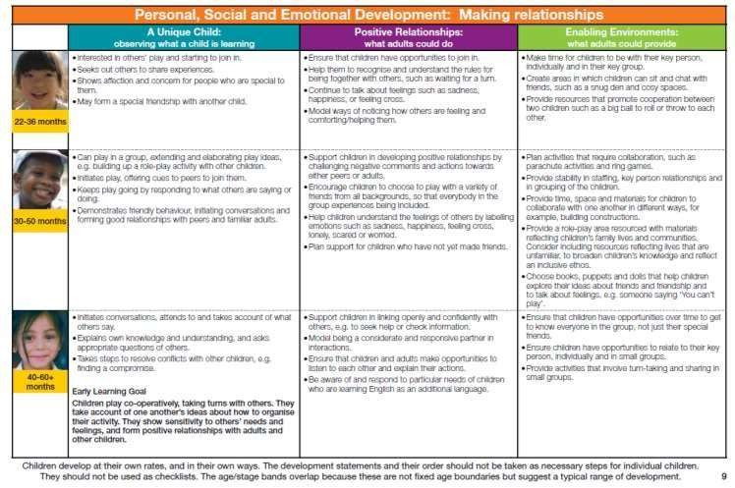

The development of positive relationships is a key strand that runs through every area of learning in the early years. There is a specific learning intention about families.

This contributes to the early learning goal: showing sensitivity to others needs and feelings.
Learning Intention
To recognise that all families are different
Learning Outcomes
Identify different members of the family
Understand how members of

a family can help each other Resources
The Family Book, Todd Parr Families pictures

Appendix 2: Primary and Secondary Expectations – from the PSHE Association

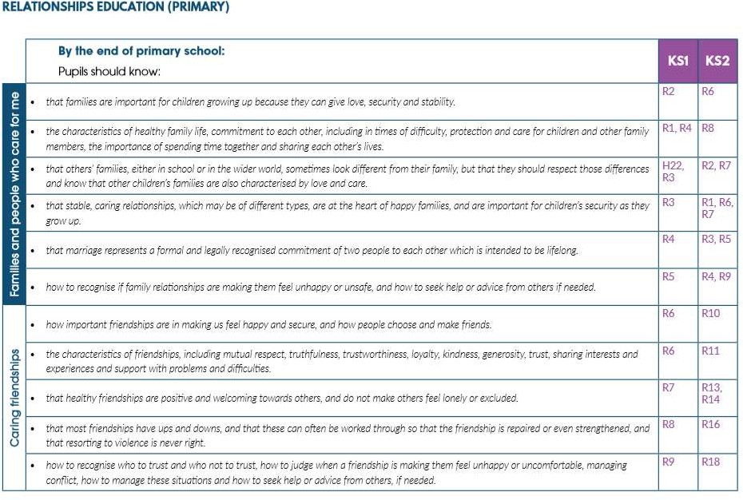

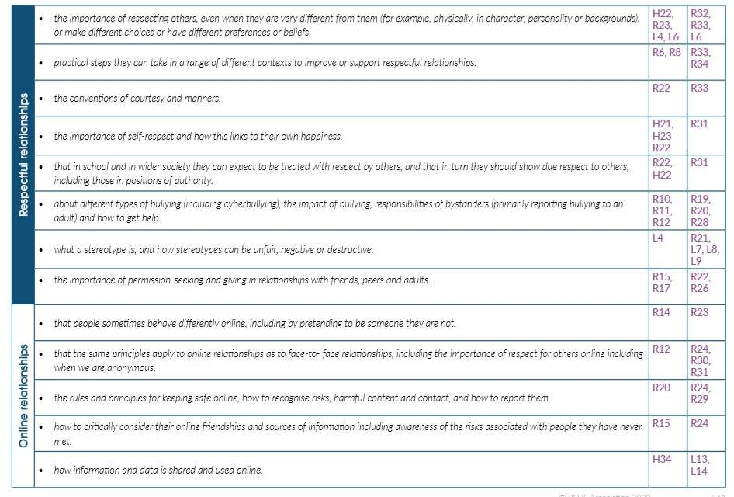

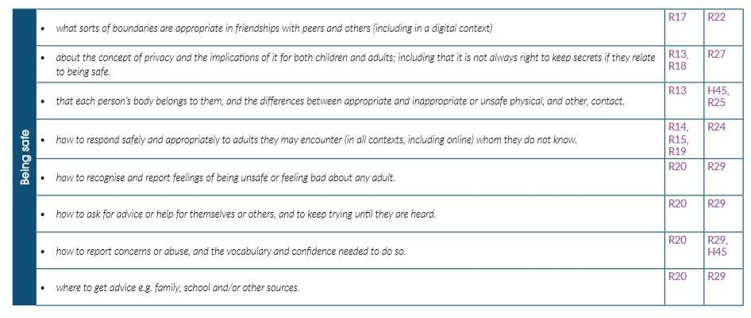

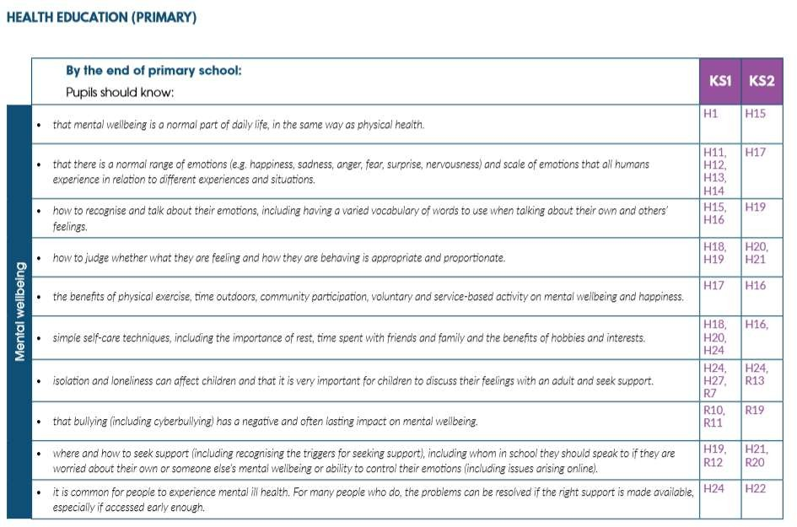

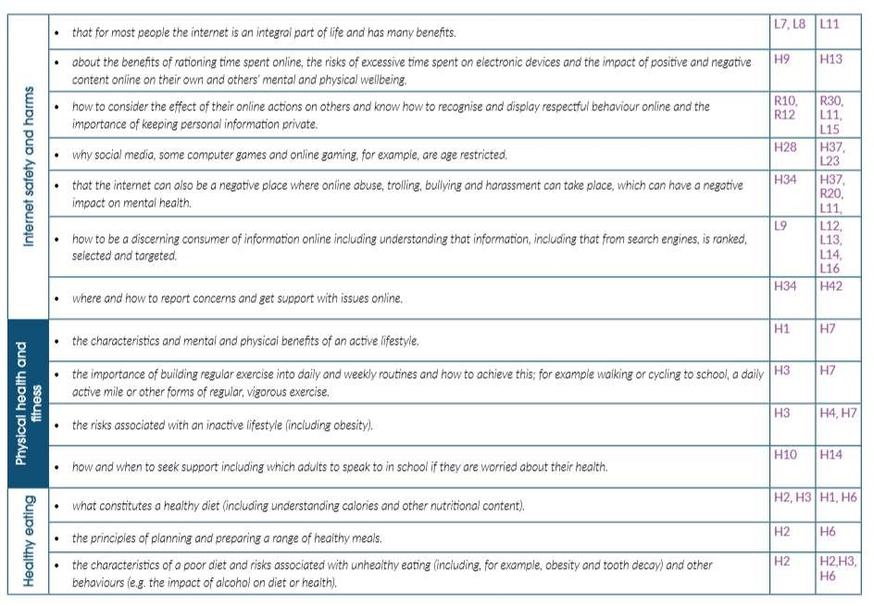

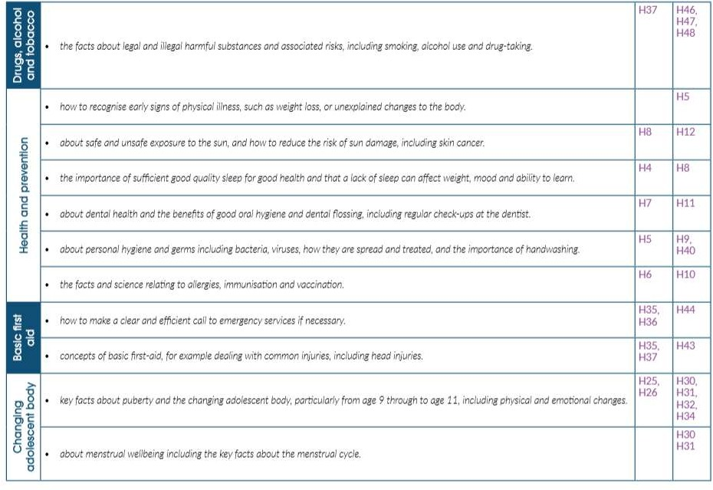

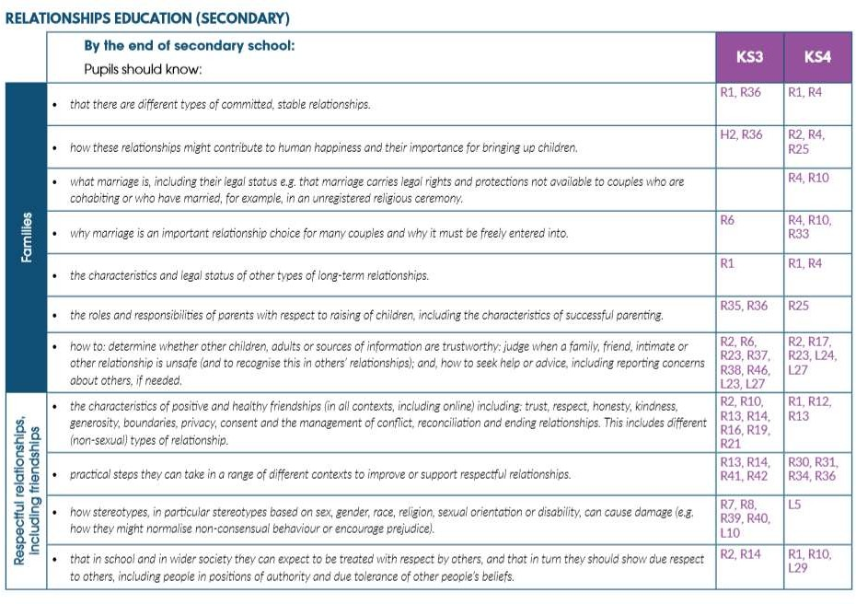

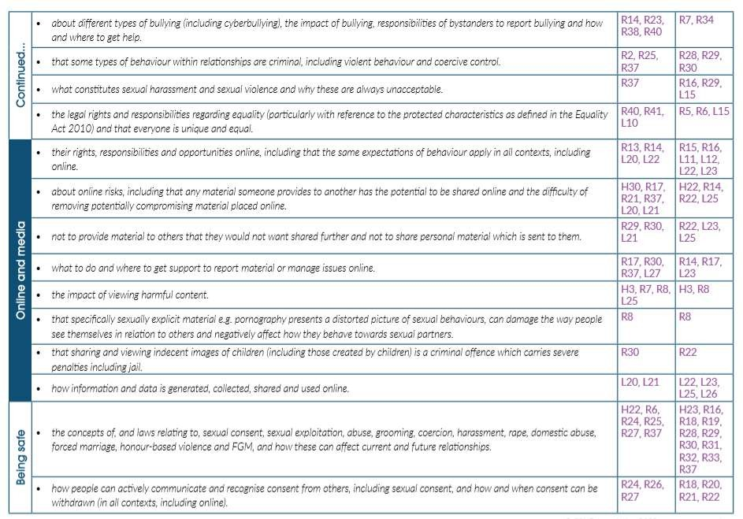

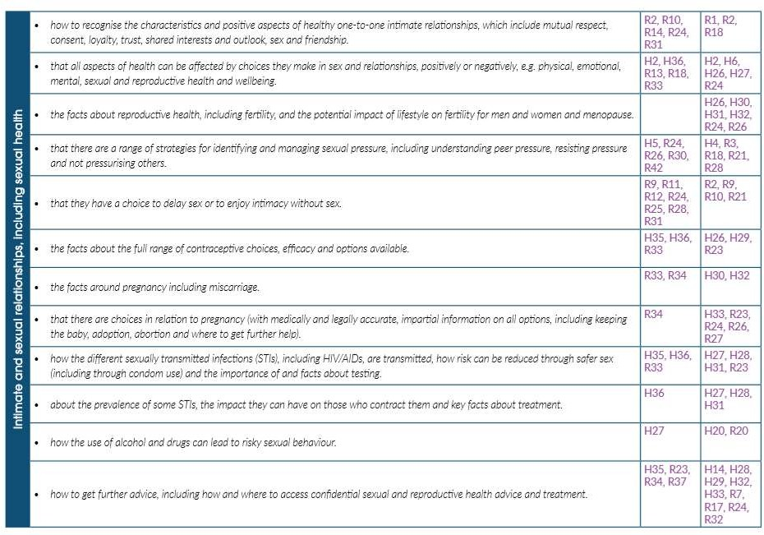

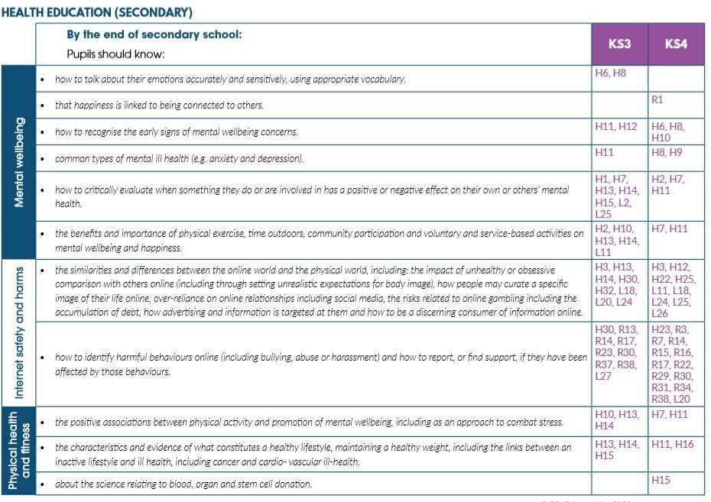

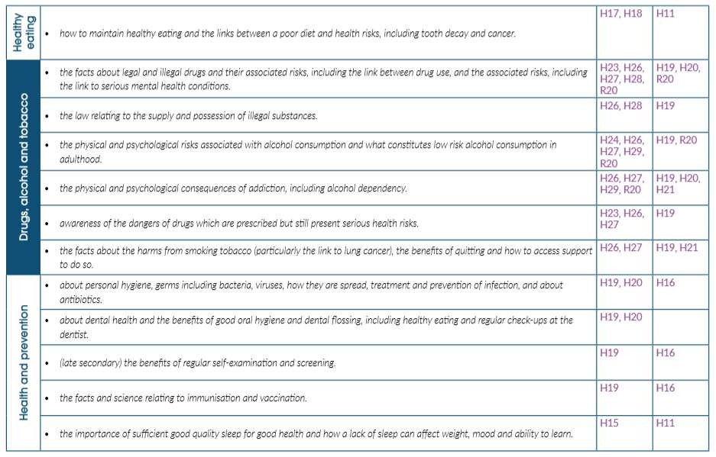

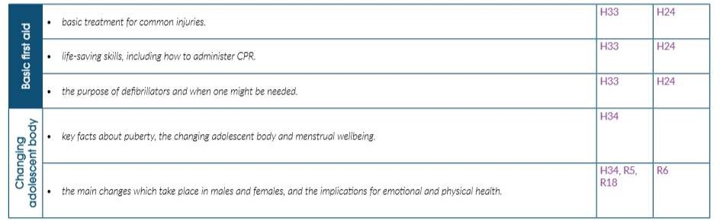

Appendix 3: Parent Form

TO BE COMPLETED BY PARENTS

XX Academy Withdrawal from Sex Education
Name of child |  | Class
Name of parent |  | Date
Reason for withdrawing from sex education
Any other information you would like the school to consider
Parent signature

TO BE COMPLETED BY THE SCHOOL
Agreed actions from discussion with parents | Include notes from discussions with parents and agreed actions taken.

Appendix 4
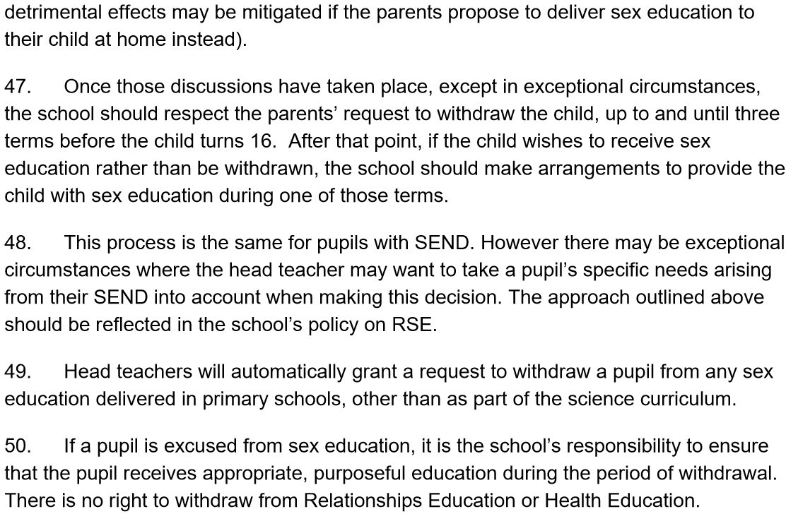
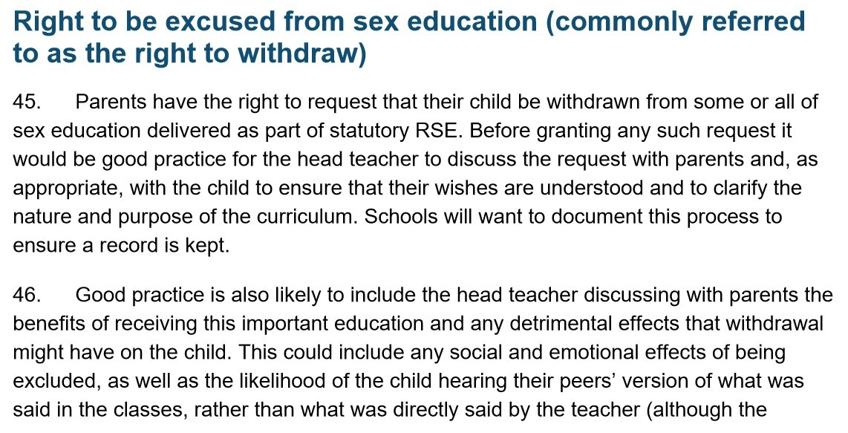

Appendix 5

Policy Development Template

This policy into practice has been developed in consultation with staff, pupils, parents and appropriate local stakeholders. The consultation and policy development process involved the following steps:

Consultation process with Stakeholders. | - Draft policy sent for review to Curriculum director of Education at GAT  - Review with Academy SLT and Curriculum lead  - Draft policy sent to all staff for feedback  - Teachers to consult with pupils as appropriate to their needs.  - Consultation with school council on when and how it is taught  - Draft Policy published on the website and parents made aware through
group call.
- Send draft policy for review by AAC
 | (The council currently includes 4 parents)
 | - Parents invited into school to review resources and discuss the planning
 | and policy further

Drafting of policy into practice for the academy – a member of staff pulled together all relevant information including relevant national and local guidance and feedback from the consultations and drafted the policy before publishing the final version.

