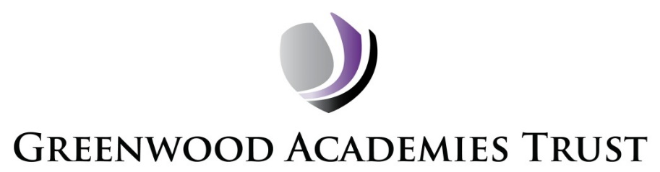

Consultation Report on the Proposal to expand the SEND provision at Nethergate Academy, Clifton, Nottingham

This report summarises the findings of a public consultation about the proposal to expand the SEND provision at Nethergate Academy, Clifton, Nottingham. The consultation ran for a total of four weeks from 10 June 2019 to 5 July 2019.

1. The Proposal
Nethergate Academy is a co-educational academy in the City of Nottingham which provides high-quality education for children and young people with special educational needs from age 5-19. Nethergate Academy has highly experienced and dedicated teaching staff who deliver an exciting and varied curriculum which ensures that learners have every opportunity to reach their full potential and learn the key skills to succeed in life. The academy is divided into 4 distinct phases: Primary (3 classes), KS3 (3 classes), KS4 (3 classes) and 6th Form (3 classes).

The proposal is to provide an additional 48 places for pupils with ASD (Autistic Spectrum Disorder) from 1 September 2020. This will include the construction of a new building which will be fully funded by Nottingham City Council as part of their SEND Strategy. The Local Authority are planning to admit 8 additional pupils per year until at full capacity, by 2024.The academy currently offers places for pupils with moderate and complex learning difficulties; many have additional needs (including Autism, social and emotional, communication, sensory and/or medical needs).

2. Consultees

A letter was sent to parents/carers of pupils at the Academy, local residents on Swansdowne Drive, all other schools and academies within the Nottingham City area, Nottingham City Council and Nottinghamshire County Council, local residents and local community groups and centres in the local area informing them of the proposal. The letter also included details of how to respond to the consultation and gave an invite to attend a public consultation meeting which was held on 24 June.

Letters were also sent to all staff and Trade Unions.

Information was added to the Nethergate Academy and the Greenwood Academies Trust websites at the start of consultation period. The Local Authority also circulated the information in the 'Local Offer' directory online.

3. Key themes coming out of the consultation
There is general support for the proposal to provide extra spaces for young people with additional needs. However, a number of issues and concerns were raised during the consultation. These were specifically raised by neighbours on Swansdowne Drive and reinforced by the local ward counsellor on their behalf. The main issues were in relation to:

- The need to address school transport, its impact on the local residents and the importance of getting vehicles off the road and onto the school site for dropping off and picking up children.
- Concerns about staff parking on the road outside of school, worries of the impact of additional staff cars as a result of the expansion and the intention to seek a residents’ only parking scheme in the local area.
- Impact of the construction project in relation to construction traffic and noise.

3.1 Parents/Carers and Community Consultation Findings
Notes were taken at the public meeting to capture residents’ comments and views about the impact of school transport and staff cars on their road. It also included written contributions from residents and 2 local councillors. The issues raised are noted above (section 3).

Plans for the new building and site re-design were available to view at the event.

The proposal has also been supported by 2 local schools.

No comments have been received from parents/carers.

3.2 Staff Consultation Findings
No comments have been received from staff at the Nethergate Academy.

3.3 Academy Advisory Council Consultation Findings
Academy Advisory Council (AAC) have been kept informed and updated on the consultation and the plans. The AAC is fully supportive of the proposal.

3.4 Pupil Consultation Findings
No comments have been received from pupils.

  - Support from the Local Authority
We have full support from the Local Authority. A planning application has been submitted.

4. Conclusion and Next steps

There have been some issues raised from local residents about parking and it has been agreed to set up regular meetings during the development. The development of a travel plan will also help address all travel for both young people and staff, encouraging a sustainable approach.

Following review of the responses to the consultation, Greenwood Academies Trust will be submitting a significant change full business case to the DfE for approval from the Secretary of State for Education.
Details of the outcome will be posted on the Greenwood Academies Trust website and Nethergate Academy website. Letters will also be sent to parents/carers, staff, unions and the local residents.

Dated: 10 July 2019

